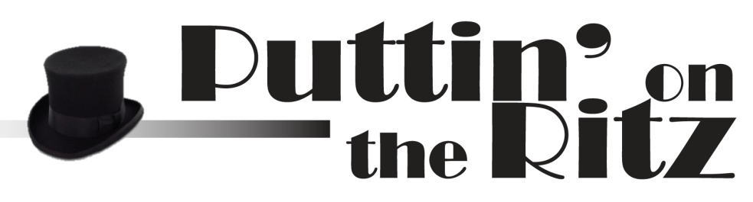

Hors D’oeuvres
(per 25 pieces)
Baked Brie Amandine $21.25
Beef Brochettes 26.25
Beer Battered Mushrooms 11.25
Cajun Fish Fingers 27.50
Cherry Tomatoes w/Caviar 33.75
Cherry Tomatoes w/Tuna 21.25
Chicken Wings (Baked, Fried, BBQ, Buffalo) 20.00
Chicken Cordon Bleu Bites 27.50
Chicken Hawaiian 27.50
Chicken Salad Encrute 26.25
Chicken Fingers 27.50
Coconut Chicken 23.75
Coconut Shrimp 33.75
Cucumber Cups w/Caviar 33.75
Egg Rolls 27.50
Empanadas 21.25
Finger Sandwiches 21.25
Garlic Cheese on Crackers 21.25
Ham Biscuits 27.50
Ham Roulades 15.00
Hot Pepper Jelly Chicken 21.25
Italian Meatballs 15.00
Italian Sausage 15.00
Jalepeño Poppers 15.00
Kielbasa 21.25
Mini Crab Cakes 27.50
Mini Tacos 21.25
Mini Quiche 21.25
Mozzarella Cheese Sticks 21.25
Mushroom Caps w/Crabmeat 40.00
Pigs in a Blanket 13.75
Potato Skins 26.25
Pot Stickers 15.00
Quesadillas (chicken or vegetable) 26.25
Rumaki (chicken liver in bacon) 21.25
Salami Cornets 21.25
Salmon Cakes 26.25
Sausage Stuffed Mushrooms 21.25
Scallops in Bacon 27.50
Smoked Salmon Mousse on Crackers 40.00
Smoked Salmon Tartar 27.50
Smoked Trout Mousse on Crackers 33.75
Spring Rolls 27.50
Steak Tartar 27.50
Stuffed Celery 13.75
Stuffed Cucumber Cups 13.75
Swedish Meatballs 15.00
Sweet and Sour Meatballs 15.00
Taco Balls 15.00
Fried Wontons 26.25
Melon Wrapped in Prosciutto Ham 21.25
Spankopita 21.25
Spinach Crepes 15.00
Sushi 33.75
Water Chestnuts in Bacon 15.00
Yakatori (chicken skewers w/dipping sauces) 21.25
Platters for 50
Cheese and Crackers $135.00
Meat and Cheese 160.00
Fruit and Cheese 160.00
Fresh Fruit Platter 135.00
Smoked Salmon w/Cream Cheese, Mustard Sauce, Capers, and Red Onions 185.00
Vegetables w/Dip 95.00

Dips & Spreads
(To Serve 50)
Spinach Dip w/French Bread Sticks $70.00
Chocolate Fountains
Service for 50 $185.00
- Includes strawberries, bananas, pineapple, apples, marshmallows, pound cake, and pretzel rods.
- Your choice of up to 3 chocolates:
- White chocolate, dark chocolate, milk chocolate, caramel

Prices may change, contingent upon market price of food.

